Some TLC For A Window into East Hampton History at Abandoned Cemetery
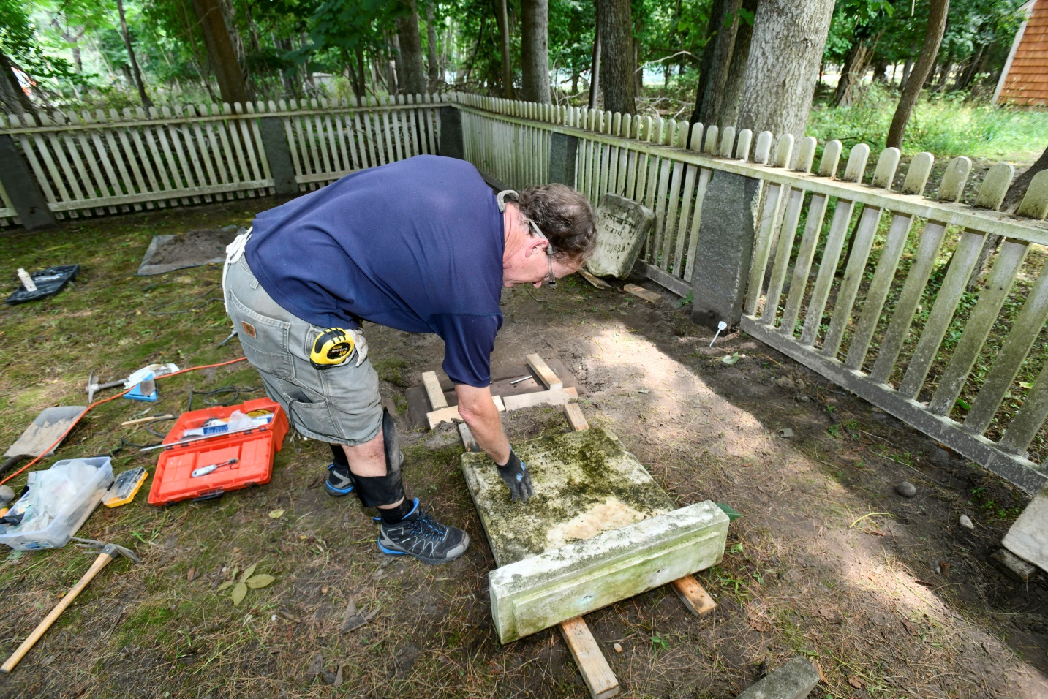
Michael Wright on Jul 15, 2020

Somewhere in a tiny cemetery wedged between the shoulder of Old Stone Highway and the entrance to the Springs School, lie the remains of a little girl, just 11 years old when she died and was buried, and, seemingly, left behind by her family when they moved away.
The white marble headstone that once marked the final resting place of Cora Bell King appears to have been separated from her actual grave at some point in the 135 years (as of August 2) since she was laid to rest. For many years, possibly decades, it has simply leaned against a tree.
Lifting the small stone gently last week, Joel Snodgrass exposed the broken bottom, where the epitaph is interrupted by a rough edge of cleaved marble.
“So, we don’t know where the broken off portion is,” said Mr. Snodgrass, an architectural conservator by trade and a cemetery restoration expert in what might be described as his free time. “Typically, when you find stones that don’t appear to be in their original location, you try not to move them unless there is due cause — something that tells you where it belongs.”
The concrete base, likely with the missing portion of her headstone attached to it, is presumably buried somewhere beneath the soil of the small cemetery plot, known as the Hedges Parsons Cemetery. All of the other dozen graves in the cemetery bore the surname of the Parsons family, so none appeared to be her immediate family members, which might have lent a hint about where the base may be.
With a long wire probe, Mr. Snodgrass could feel about, but with little direction about where to poke it, stumbling upon the narrow piece of concrete would be a shot in the dark. He went about his other chores.
With fellow historic preservationists Zachary Studenroth and Kurt Kahofer, Mr. Snodgrass was at the Hedges Parsons Cemetery to give it a sorely needed facelift. Many of the 13 headstones and footstones — arranged to face east to the rising sun so the return of Christ wouldn’t be missed — are broken, toppled over or left leaning precariously. They are straightened, pinned with steel rods to their original bases or glued where they are cracking. Those that are stable, are due for a good cleaning.
There are signs of past efforts at tidying up over the 120 years sine the last burial there. Some stones have been repaired with concrete or mortar — potentially causing even more damage — some have been propped up against their original bases and some had clearly been moved and put back at the head or foot of the wrong grave.
“This is a very small site, but it has a pretty good cross section of the problems we typically encounter,” Mr. Snodgrass said, as he wiped sweat from his brow with a dirty forearm and turned to the next stone in need of attention.
The three men, who constitute the Burial Ground Preservation Group, are leading a gradual effort to address the array of issues at East Hampton Town’s many such small cemeteries. Last year, they tackled the Van Scoy plot deep in Northwest Woods, and there are at least a half-dozen others nearby in Springs.
Mr. Studenroth, the former Southampton Town historian, led a sprawling restoration effort of all the historic cemeteries in that town, which spawned a robust public-private partnership and fundraising effort that continues today. Working off a 2009 report on East Hampton’s cemeteries, his small group and East Hampton Town Councilman David Lys have begun plotting a gradual parallel effort, on a shoestring budget for now.
Family cemeteries containing just a handful of gravesites were common before the 20th century, when families that lived miles from hamlet centers, in places like The Springs, Northwest and Montauk, would carve out their own burial grounds so their loved ones would be nearby.
In many parts of the country, those gravesites would become parts of private property and were often blotted out by development. But in New York, all “abandoned” cemeteries that didn’t have dedicated trustee boards to manage them, were deeded to their surrounding municipalities.
Mr. Lys said that he hopes to draw back the curtains from these small windows into the past.
The Van Scoy cemetery was chosen as the first subject —a decision that led to a tiff between the Town Board and former Town Historian Avril Geus, who was removed from her post by the board in January — because it contained a “patriot stone” marker of someone who had fought in the Revolutionary War. Also, because it was on the town trails system, it was ripe to become a more visible landmark.
The Hedges Parsons Cemetery is on a heavily trafficked stretch of roadway, directly adjacent to the Spring School driveway, but is little noticed. Mr. Lys said it will be adorned with a new sign announcing its presence and significance to Springs.
“We want people to know about these places, we want them to come and see them,” Mr. Lys said. “We want you to walk into these places. It’s not morbid, it’s good to walk into those cemeteries. That’s our history.”

